Updating Sphinx pages, after making html to update IDF docs to new colours
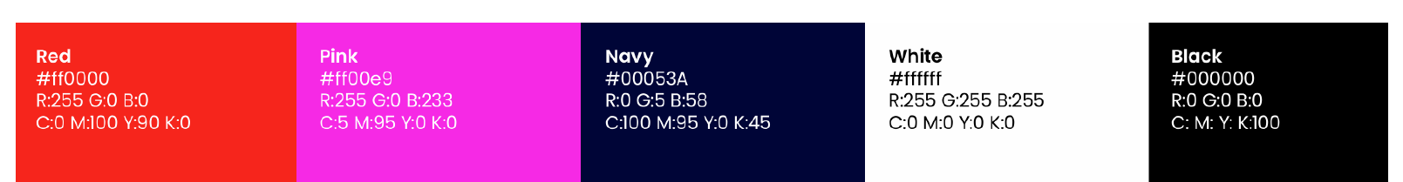
Colour changes
Find and replace in docs/_static/theme.css AFTER RUNNING MAKE HTML
(This should be possible to put into custom.css file, but I can’t get that to read and make the change automatically during make html process)
These changes are also saved in a file docs/IDFtheme.css in the github; use that to replace docs/_static/theme.css with to make the changes more easily.
Default colours (Find) | IDF colours (Replace) | Where on screen
#3091d1 (blue) | #00053A  (NAVY) | - Blue text in header  - Blue text in bottom contents list / url in text  - Header link icons
#2980b9 (blue) | #00053A  (NAVY) | - Top left box
#55a5d9 (blue) | #f00  (RED) | - Blue ‘Contents:’, left bar
#9b59b6 (blue) | #00053A  (NAVY) | - Clicked URLs

Changes the page from:
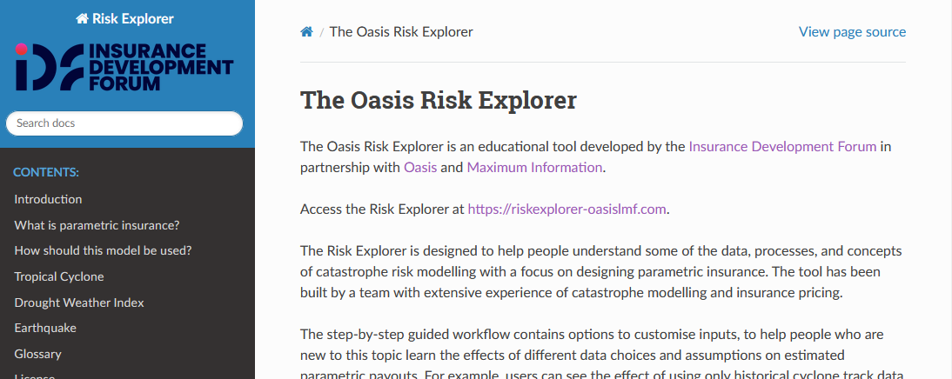
To:
